
876 Screens Ltd
Technical Specification Document
876 Screens Cinema Ticket Platform
Version 1.0
Author: Kevin Darby

Created: March 2026
Last Updated: March 2026
Issue Reference: 876S-TS-001

Table of Contents

INTRODUCTION 3
Overview / Problem Description 3
Stakeholders 3
Terminology/Glossary 3
USE CASES 4
Use Case 1: User Registration 4
Use Case 2: Browse Movies 4
Use Case 3: Book Cinema Ticket 5
Use Case 4: Admin Manage Movies 5
USER STORIES 6
ENTITY RELATIONSHIP DIAGRAM (ERD) 7
Entity Descriptions 7
Relationships Between Entities 8
Description of Constraints 8
ARCHITECTURE DIAGRAM 10
MOCK-UPS 11
Conclusion 14

INTRODUCTION

Overview / Problem Description
Many cinema-goers in Jamaica still rely on purchasing movie tickets directly at theatre locations. This often results in long queues, limited visibility of available showtimes, and inconvenience when planning movie outings in advance. 876 Screens is an online cinema platform designed to allow users to:
- Browse available movies
- View cinema locations
- Select showtimes
- Purchase movie tickets online
The platform aims to simplify the cinema going experience by enabling users to reserve tickets digitally before arriving at the theatre.

Stakeholders
The 876 Screens platform involves several key stakeholders who contribute to its functionality and success. These include users who purchase tickets, supervisors who manage movies and schedules, and system administrators who oversee the platform.
- Cinema Customers (Users)
- Supervisors
- System Administrators

Terminology/Glossary
Term | Definition
Actor | A person or external system interacting with the application
Use Case | A description of interactions between a user and the system
User Story | A simple description of a feature from the user's perspective
ERD | Entity Relationship Diagram used for database design
DBMS | Database Management System
API | Application Programming Interface

USE CASES
Use cases describe how users interact with the 876 Screens system to achieve specific goals. They outline the actions performed by users and the system’s responses, helping to clearly define system functionality.

Use Case 1: User Registration
Actors
- Cinema Customer
Basic Flow
- Customer selects the Register option.
- Customer enters personal information (name, email, password).
- System validates input data.
- System creates a user account.
- Customer receives confirmation of successful registration.

Use Case 2: Browse Movies
Actors
- Cinema Customer
Basic Flow
- Customer visits the homepage.
- System displays currently available movies.
- Customer selects a movie.
- System displays movie details including showtimes and cinema locations.

Use Case 3: Book Cinema Ticket
Actors
- Cinema Customer
Basic Flow
- Customer selects a movie.
- Customer chooses cinema location.
- Customer selects showtime.
- Customer proceeds to book ticket.
- System processes the request.
- System confirms booking.
- System generates a digital ticket.

Use Case 4: Admin Manage Movies
Actors
- Administrator
Basic Flow
- Admin logs into admin dashboard.
- Admin adds or updates movie listings.
- Admin sets showtimes and cinema locations.
- System updates movie listings on the platform.

USER STORIES
User stories describe the system from the perspective of the end users. They capture what users want to achieve and the value the system provides, helping to guide the design and development of the platform.
- As a cinema customer, I want to browse movies so that I can see what is currently showing.
- As a cinema customer, I want to select a showtime so that I can book a movie.
- As a cinema customer, I want to book tickets online so that I can avoid long queues.
- As an administrator, I want to manage movie listings so that the system displays accurate showtimes.
- As a cinema customer, I want to receive a digital ticket so that I can easily enter the cinema.

ENTITY RELATIONSHIP DIAGRAM (ERD)

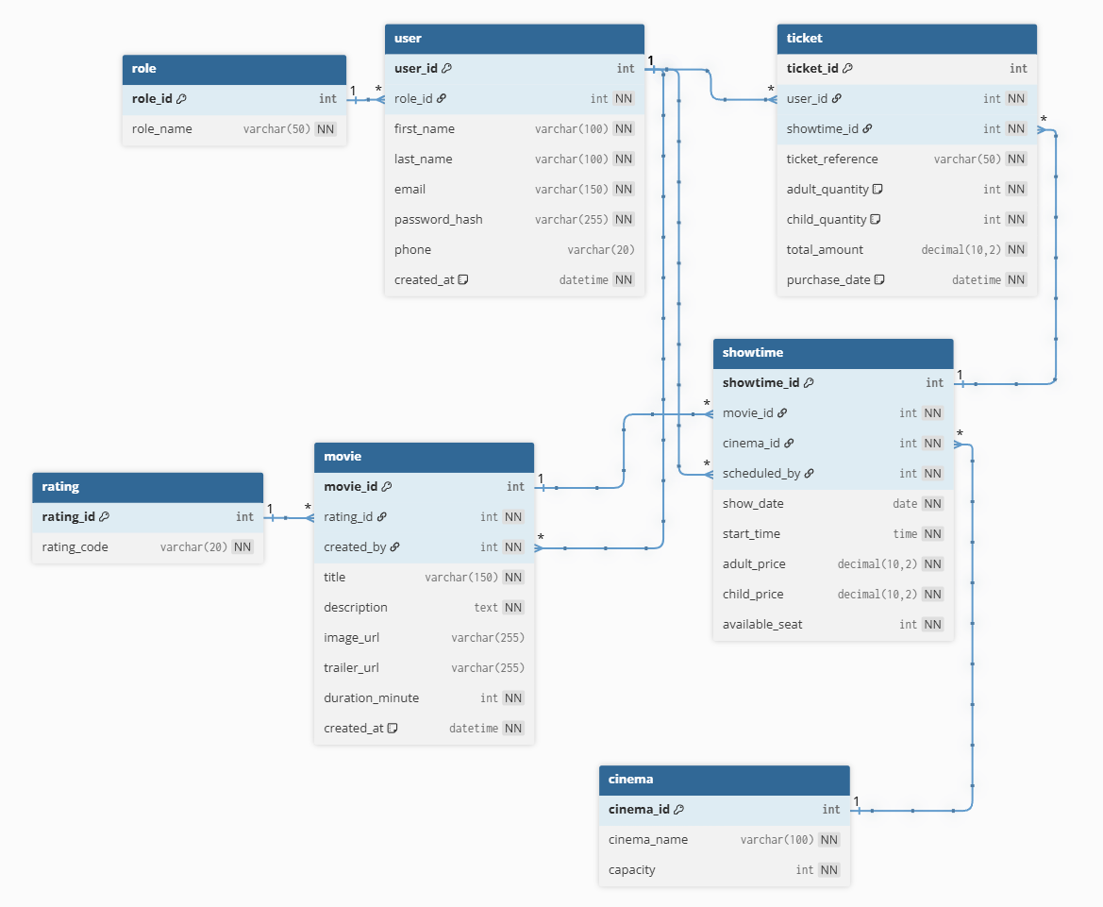

Entity Descriptions
Entity | Description
Role | Stores different user roles such as Admin, Supervisor, and User. Determines access levels and permissions within the system.
User | Contains user details such as name, email, password, and role. Users can either manage the system or purchase tickets.
Rating | Stores movie classification ratings (e.g., G, PG-13, Adults Only) to guide users on movie suitability.
Cinema | Represents cinema locations or halls (e.g., Cinema 6, 7, 8) where movies are shown.
Movie | Stores movie details including title, description, duration, image, trailer URL, and rating.
Showtime | Represents scheduled screenings of movies, including date, time, cinema, and ticket pricing.
Ticket | Represents a booking transaction made by a user, including ticket quantities and total payment.

Relationships Between Entities
- Role → User (1: Many)
One role can be assigned to many users, but each user has only one role.
- User → Movie (1: Many)
One admin or supervisor can create/manage many movies, but each movie is created by one user.
- Rating → Movie (1: Many)
One rating can be assigned to many movies, but each movie has only one rating.
- Movie → Showtime (1: Many)
One movie can have multiple showtimes, but each showtime is linked to one movie.
- Cinema → Showtime (1: Many)
One cinema can host multiple showtimes, but each showtime occurs in one cinema.
- Showtime → Ticket (1: Many)
One showtime can have many ticket bookings, but each ticket is linked to one showtime.
- User → Ticket (1: Many)
One user can purchase many tickets, but each ticket belongs to one user.

Description of Constraints
- Role → User
This constraint ensures that each user has only one assigned role in the system, such as Admin, Supervisor, or User.
- User → Movie
This constraint ensures that every movie record is associated with the user who created or manages it.
- Rating → Movie
This constraint ensures that each movie is classified under one rating category only.
- Movie → Showtime
This constraint ensures that every showtime is connected to a valid movie in the system.
- Cinema → Showtime
This constraint ensures that each scheduled showing is assigned to one cinema location.
- Showtime → Ticket
This constraint ensures that every ticket purchase is tied to a specific movie showtime.
- User → Ticket
This constraint ensures that each ticket transaction is linked to the user who made the booking.

ARCHITECTURE DIAGRAM
The architecture diagram provides a high-level overview of the 876 Screens system, showing how users interact with the platform and how different roles manage its operations. It illustrates the main components of the system and the flow of data between them.
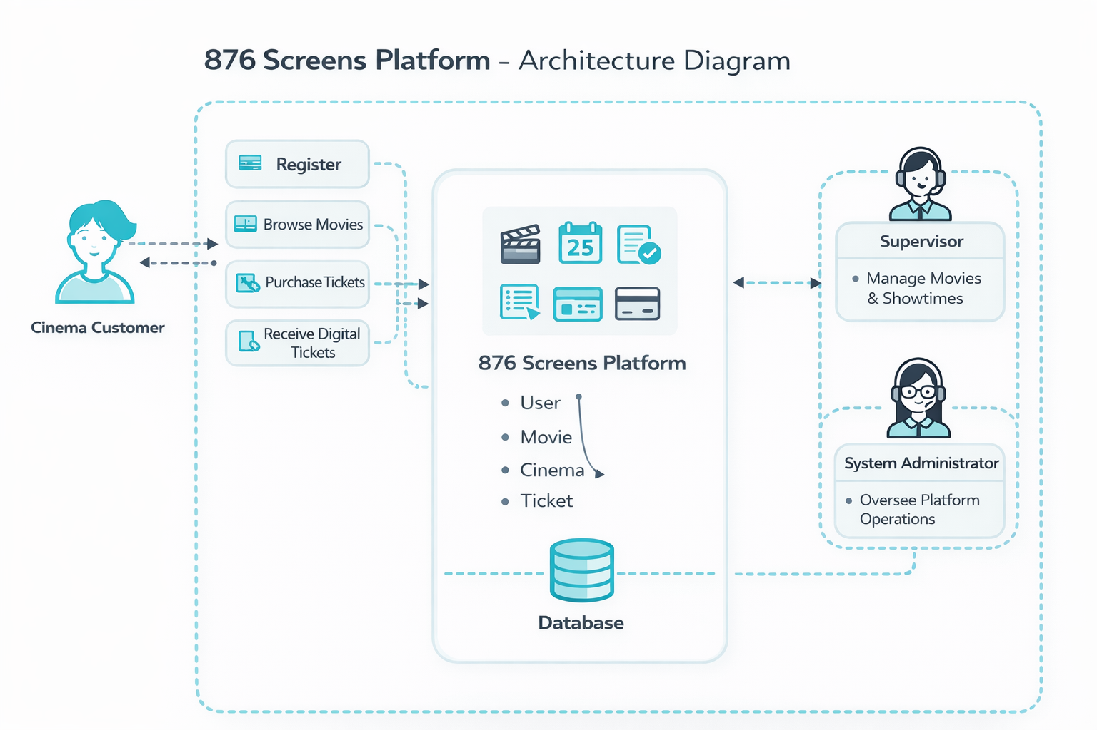

MOCK-UPS
The following mock-ups represent the visual design and layout of the 876 Screens platform, developed using a mobile-first approach. This ensures that the system is optimized for smaller screens, providing a responsive and user-friendly experience on mobile devices before scaling up to larger screens such as tablets and desktops. The designs focus on simplicity, accessibility, and ease of navigation to enhance the overall user experience.

Homepage (mobile layout)
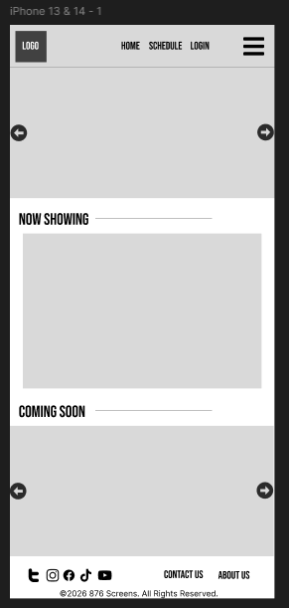
Homepage (tablet layout)
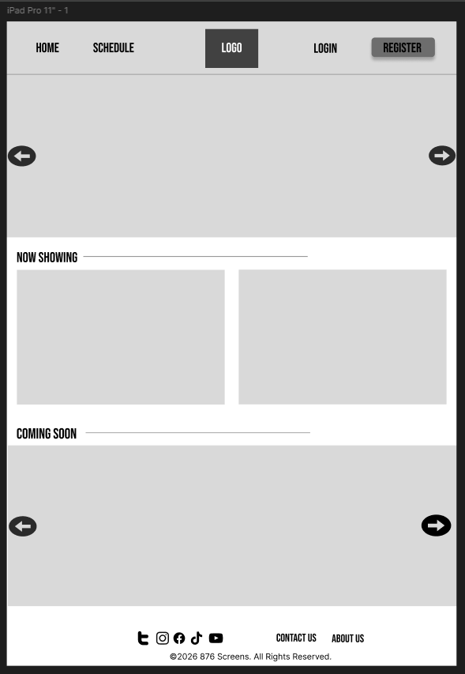
Homepage (desktop layout)
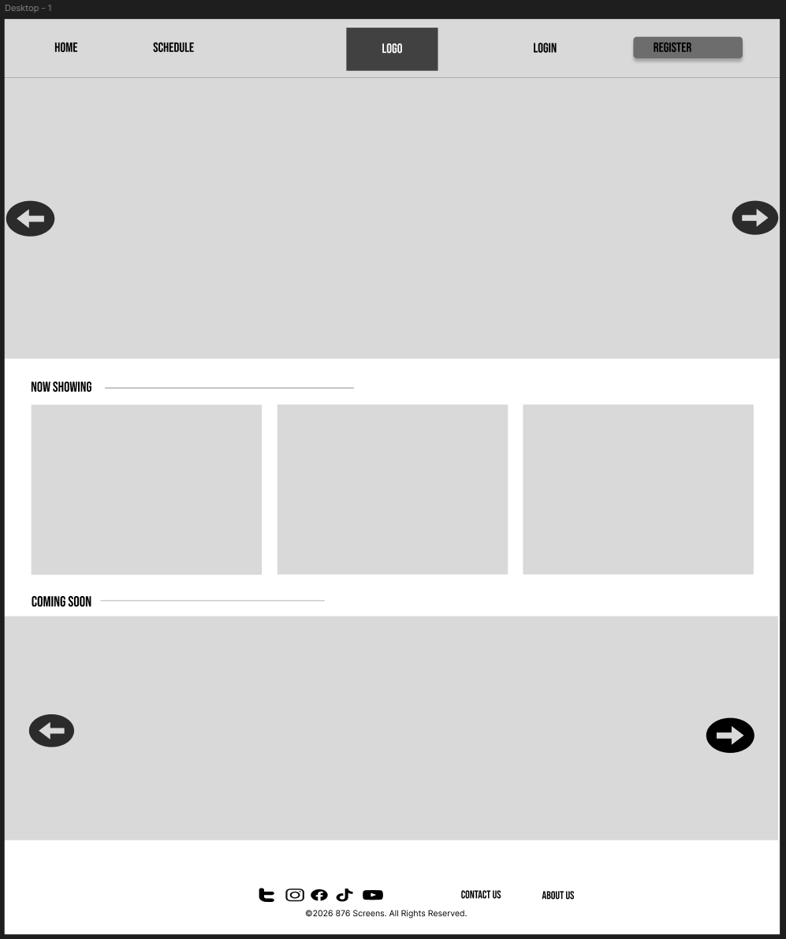

Conclusion
In developing this technical specification for the 876 Screens platform, we have outlined a structured approach to creating an online cinema ticketing system. The project defines the system’s scope, identifies key user roles, and presents essential use cases and user stories that guide its functionality.
The design of the system, supported by the Entity Relationship Diagram (ERD), provides a clear understanding of how data is organized and how different components of the platform interact. This ensures a solid foundation for database development and system implementation.
876 Screens is designed to simplify the cinema experience by allowing users to browse movies, view schedules, and book tickets online. At the same time, administrators and supervisors are provided with tools to efficiently manage movies and showtimes.
Overall, the project aims to deliver a simple, efficient, and user-friendly platform that improves accessibility and convenience for cinema goers while maintaining proper system structure and data integrity.

